**Assignment #8**

**Non-Seasonal ETS and ARIMA Laboratory**

Due: Wed. Nov. 1 (by 11:59pm)

(40 pts. Total)

You are working for a firm producing electrical generation equipment, and you have been tasked with an estimation of the medium-term potential of the Chinese market through the end of 2020.

China is one of the markets that has experienced the most growth in electricity generation. The plot below was elaborated using OECD data, and it shows the accelerated growth of the country-wide electricity generation capacity as a consequence of the high rate of sustained economic growth.

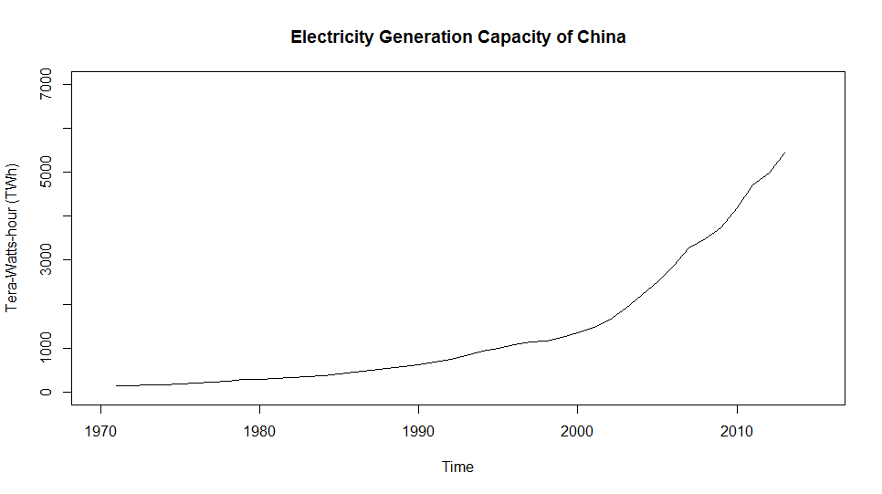China’s generation capacity surpassed the one of the US in 2011, but as the population of China is more than four times the population of the US, there is still significant growth potential for the foreseeable future. As of the end of 2013, the OECD reports the installed capacity is **5,436.6 Tera-Watt-hours** and growing fast.

This assignment asks you to estimate the investment in electricity generation of china between 1013 and 2020. To get started first upload the time series “ChinaElectricity.RData” provided with the assignment. This is accomplished using the following command:

**load**("ChinaElectricity.RData")

When you execute this command you should have Time-Series variable called CH in your Environment. This is the capacity of generation per year from 1971 through 2013 expressed in TWh. For analysis purposes we split this data into two subsets, a training set CH.tr and a testing set CH.te as follows:

CH.tr <-**window**(CH, end=2006)  
CH.te <-**window**(CH, start=2007, end=2013)

Instead of optimizing the Box-Cox parameter lambda, in this case we fit a model to the log of the demand data. This can be very easily accomplished on time-series models (ETS and ARIMA) by setting the lambda parameter equal to zero. Please set **lambda = 0** in all the models for this assignment.

1. (5 pts.) ETS model for training data:
   * Use the ets(…) function to fit the best exponential smoothing model to the training data set CH.tr. What is this model? What are the values of its parameters?



This model was an (A, A, N) model which means it had additive error, additive trend, and no seasonality, with no damping.

The values of the parameters are:

Alpha = 0.9999

Beta = 0.3065

Sigma = 0.0335

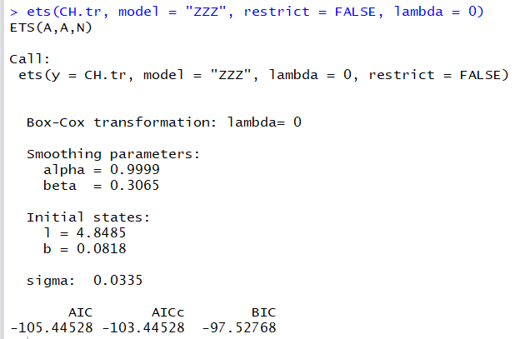

* + Use the tsdiag(…) function to examine the diagnostics of the residuals of this model. Is the model valid?

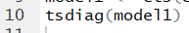

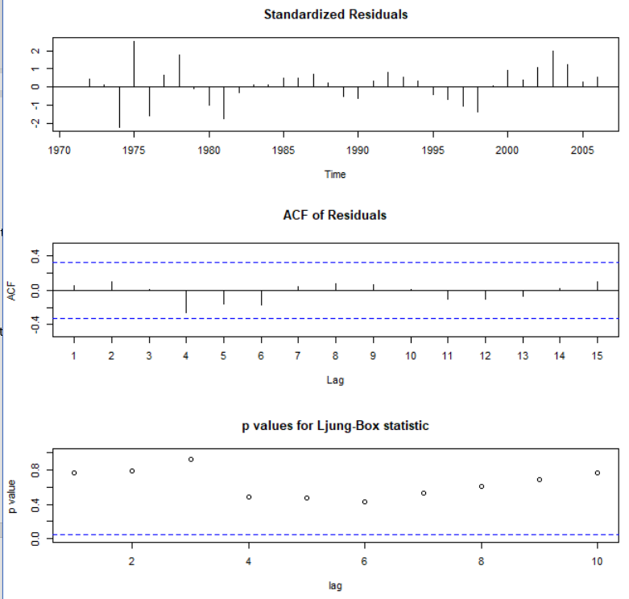

This model looks valid from the tsdiag() of the residuals. The standardized residuals are all between -3 and +3, so none are far outliers. The ACF of residuals also looks good as they are all between the blue lines. Finally, the p-values for the Ljung-Box statistics are all NOT significant, so this confirms the model’s validity—we fail to reject this model and the hypothesis that the time series is not stationary. From these three examinations of the residuals, we can conclude that the model is valid.

* + Obtain the 7 periods (years) ahead forecast for the model and overlay in red the actual capacity using a red color line.

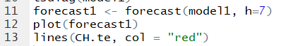

Created and plotted the forecast for 7 more periods.

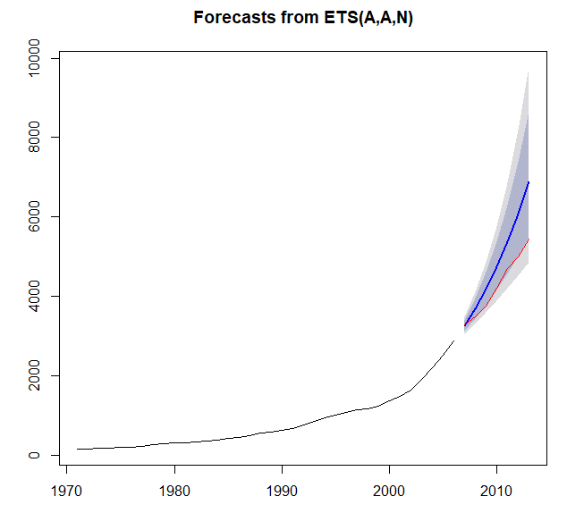

* + Use the accuracy(…) function to obtain the training and testing fit metrics for the model obtained. Based on the visual inspection of the forecast plot and the out-of-sample fit statistics comment on the forecast bias.



Based on my visual inspection of the forecast plot, the model does not do that great of a job of predicting the true data. The model predicts China’s electricity use to be much higher than it was. This means that the training data may have shown different trends and the model could not accurately see these trends with the logarithmic lambda transformation. When inspecting the out-of-sample fit statistics, we see the same issues with the fit metrics of the model. All of the fit metrics are much higher for the testing data, and they show a large MAE, MAPE, and MASE. Combining the fit statistics and the visual inspection, we can conclude that the forecast is biased toward the training set and does not accurately predict the testing data.

1. (5 pts.) Stationarity of the training set:
   * Run the adf.test(…) function on log(CH.tr) and check the p-value. Keep differencing the log-transformed training set until you can reject the hypothesis that the time series is not stationary, and hence you accept the alternative hypothesis that the series is stationary. How many times do you need to difference log(CH.tr)?

For this model, I am assuming a 5% significance level; thus, I can reject the hypothesis if the p-value is less than 0.05.

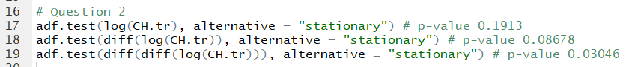

I had to difference the log(CH.tr) two times in order for the p-value to be less than 0.05. At this point, I can reject the hypothesis that the time series is not stationary. Now, it is stationary.

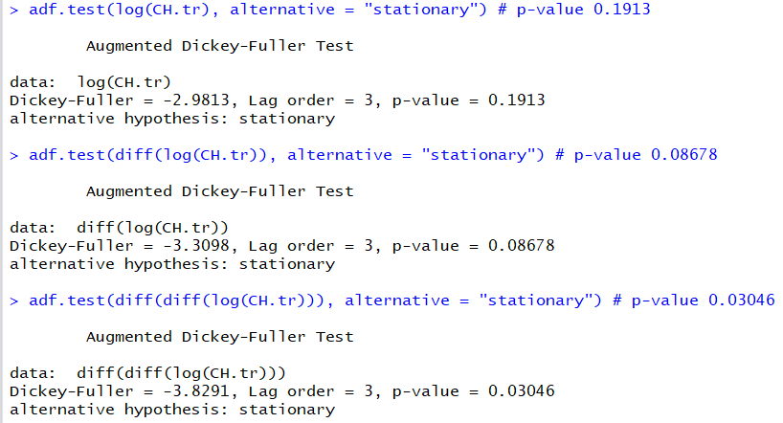

1. (5 pts.) Model Selection:
   * Use the function tsdisplay(…) on the stationary series in Question 2. Based on the ACF and PACF of the stationary series what the maximum order ( $p$ and $q$ values) in the selection of an ARIMA model for this series?

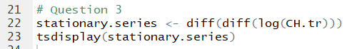

P = order of the autoregressive part

Q = order of the moving average part

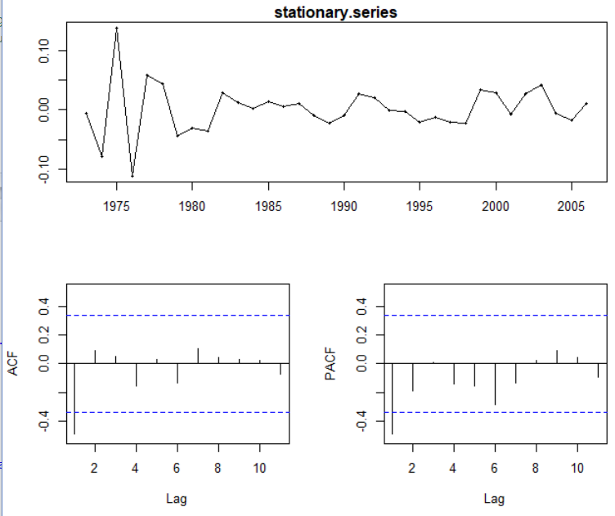

There is no clear choice suggested by the guidelines; however, we can estimate the highest possible values of p and q. It looks like the PACF plot is somewhat exponentially decaying, while the ACF plot has a significant spike at lag 1 with much smaller ACF values after. This suggests that the model may have a p = 0 and a q =1. However, you could also conclude the opposite—ACF may be exponentially decaying and PACF may just have 1 significant spike, giving a p = 1 and a q = 0. However, from both of these assumptions, we can conclude that the max value of p is 1 and the max value of q is 1, as both plots only have a significant spike when lag is 1.

1. (5 pts.) ARIMA model for the training set:
   * Use the auto.arima(…) function with lambda = 0 to select the best ARIMA model for the training set CH.tr What is the order of the selected model? What are the values of the model parameters?

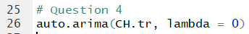

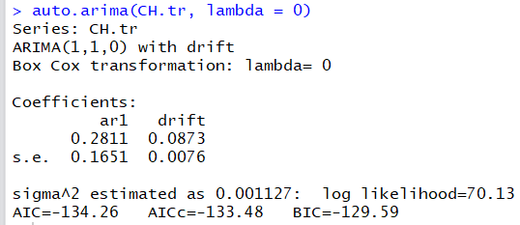

The order of the selected model is (1,1,0). P, the auto regression order, is 1. D, the degree of first differencing involved, is 1. Q, the order of the moving average part, is 0.

The values of the model parameters are:

* ar1: 0.2811
* drift: 0.0873
* sigma^2: 0.001127
  + Use the tsdiag(…) function to examine the diagnostics of the residuals of this ARIMA model. Is the model valid?



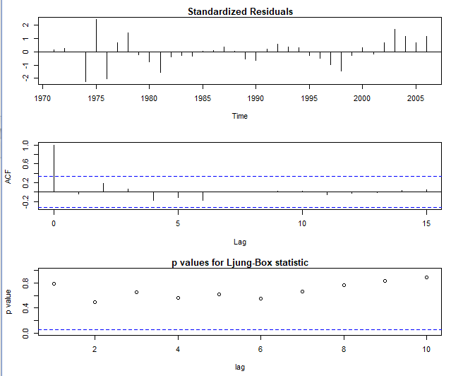

Based on the residual diagnostics, we can conclude that the model is valid. The standardized residuals are all between -3 and +3. The ACF values are all not significant, with the exception of the first value. We can ignore the first value because it is just saying the 0 lag is correlated with itself. Finally, all the p-values are not significant, so we can conclude that the model is valid.

* + Obtain the 7 periods (years) ahead forecast for the model and overlay in red the actual capacity using a red color line.

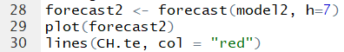

Plot the forecast with the actual data.

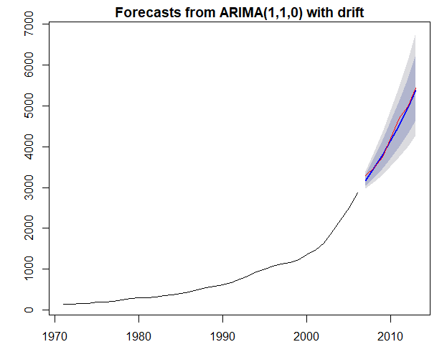

* + Use the accuracy(…) function to obtain the training and testing fit metrics for the model obtained. Based on the visual inspection of the forecast plot and the out-of-sample fit statistics comment on the forecast bias.



Based on visual inspection, the auto.arima forecast does a very good job of predicting the actual electricity values. Compared to the ETS model, the ARIMA model has much lower out-of-sample errors. The Mean Absolute Percentage Error is actually lower for the testing data than the training data. This forecast is not overly biased toward the training set. The ARIMA (1,1,0) accurately captured the trends in the training data to more accurately predict the forecast. The autoregressive component and the first differencing model more accurately predicted the trend than the ets() model. These resulted in much smaller testing set error measures. The forecast is not very biased; in fact, it was very close to the actual testing data.

* + Is it valid to compare the $AICc$ and $BIC$ of the ETS and ARIMA models to select the best model? Explain.

Yes. They are the same data, both CH.tr transformed by lambda = 0 by the log function. Because they are models on the exact same data sets, it is valid to compare the AICc and BIC of the ETS and ARIMA models.

The AICc of the ETS model is -103.44528 while the AICc of the ARIMA model is -133.48. Since the AICc of the ARIMA model is lower, the ARIMA model is a better fit. The BIC of the ETS model is -97.52768, while the BIC of the ARIMA model is -129.59. Since the BIC of the ARIMA model is lower, the ARIMA model is a better fit. Thus, because the models are on the same data, we can conclude that the ARIMA is a better model.

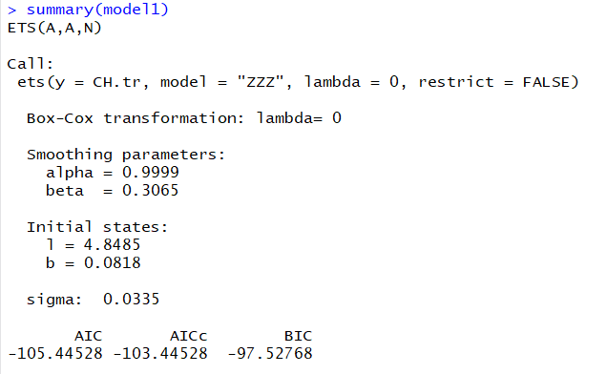

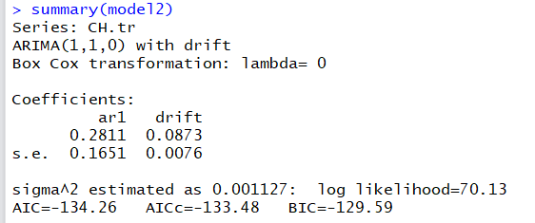

* + Based on all your comparisons what model is likely to produce better out-of-sample forecasts?

Model2, the ARIMA model, is likely to product better out-of-sample forecasts. Both models are valid according to the tsdiag() function. Based on the visual inspection of the forecast model, the ARIMA model does a better job of predicting the testing data. Based on the forecast statistics for the out-of-sample data, the ARIMA model does a much better job compared to the fit statistics of the ets() model. The AICc and BIC values also confirm that the ARIMA model did a better job of fitting the data. Based on all of these comparisons, the ARIMA model is likely to produce better out-of-sample forecasts.

1. (5 pts.) Forecasting future generation capacity:
   * Use the Arima(…) function to fit on the entire data set, CH, the same order and type of ARIMA model you obtained and tested in Question 4. What are the values of the model parameters?



I used the Arima function to fit the (1,1,0) model with drift and a lambda = 0 to the entire data set, CH.

The values of the model parameters are:

Ar1 = 0.2523

Drift = 0.0875

Sigma^2 = 0.001078

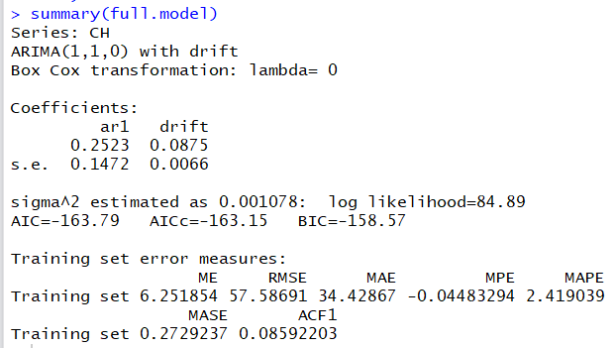

* + Use the tsdiag(…) function to examine the diagnostics of the residuals of this ARIMA model. Is the model valid?

I called the tsdiag() function on full.model.

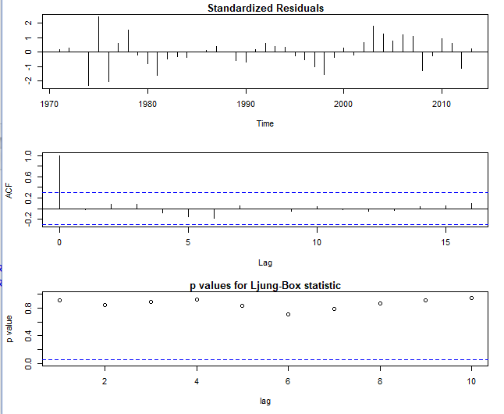

This model is valid because the standardized residuals are all between -3 and +3. The ACF values are all non-correlated, with the exception of the first lag, which is perfectly correlated with itself. The p-values for the Ljung-Box statistic are all not significant. Based on these three residual statistics, the model is valid for all three measures.

* + Calculate the forecast for 2020, plot it, and estimate the additional generation capacity that China will build between 2013 and 2020.

I created a forecast for 7 more time periods, from 2013 to 2020. I plotted this forecast as well.

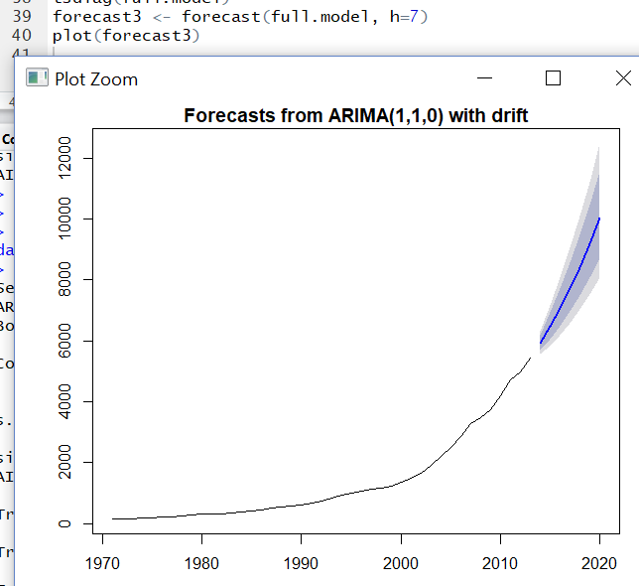

The forecast for 2020 is 10,025.964

Estimate the additional generation capacity that China will build between 2013 and 2020. As of the end of 2013, the OECD reports the installed capacity is **5,436.6 Tera-Watt-hours** and growing fast. Based on this forecast, China will build 10,025.964 – 5436.6 = 4,589.364 additional generation capacity in Tera-Watt-hours.

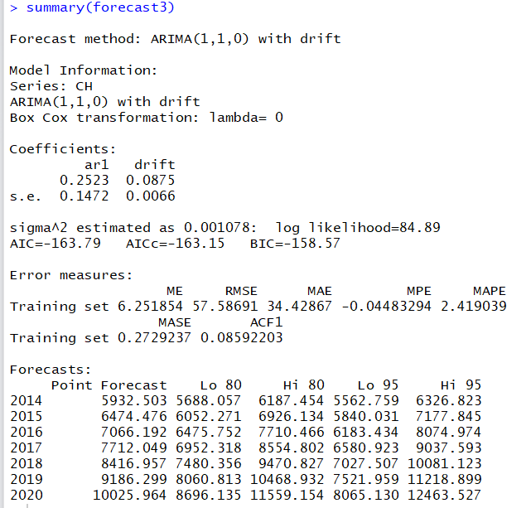

1. (5 pts.) Write the B-Polynomial representing the type and order of model in Question 5.

Type and order of model in Question 5: ARIMA (1,1,0) model with drift.

(1−𝜙­­1𝐵)(1−𝐵)𝑦𝑡=c + 𝑒t

The first part is the AR(1) order of the model. The second part is the 1st level difference of the model. The c accounts for the drift in the model. There is no MA component of the model as its order is 0.

1. (5 pts) Expand the B-Polynomial and write in explicit form the statistical model representing the data.

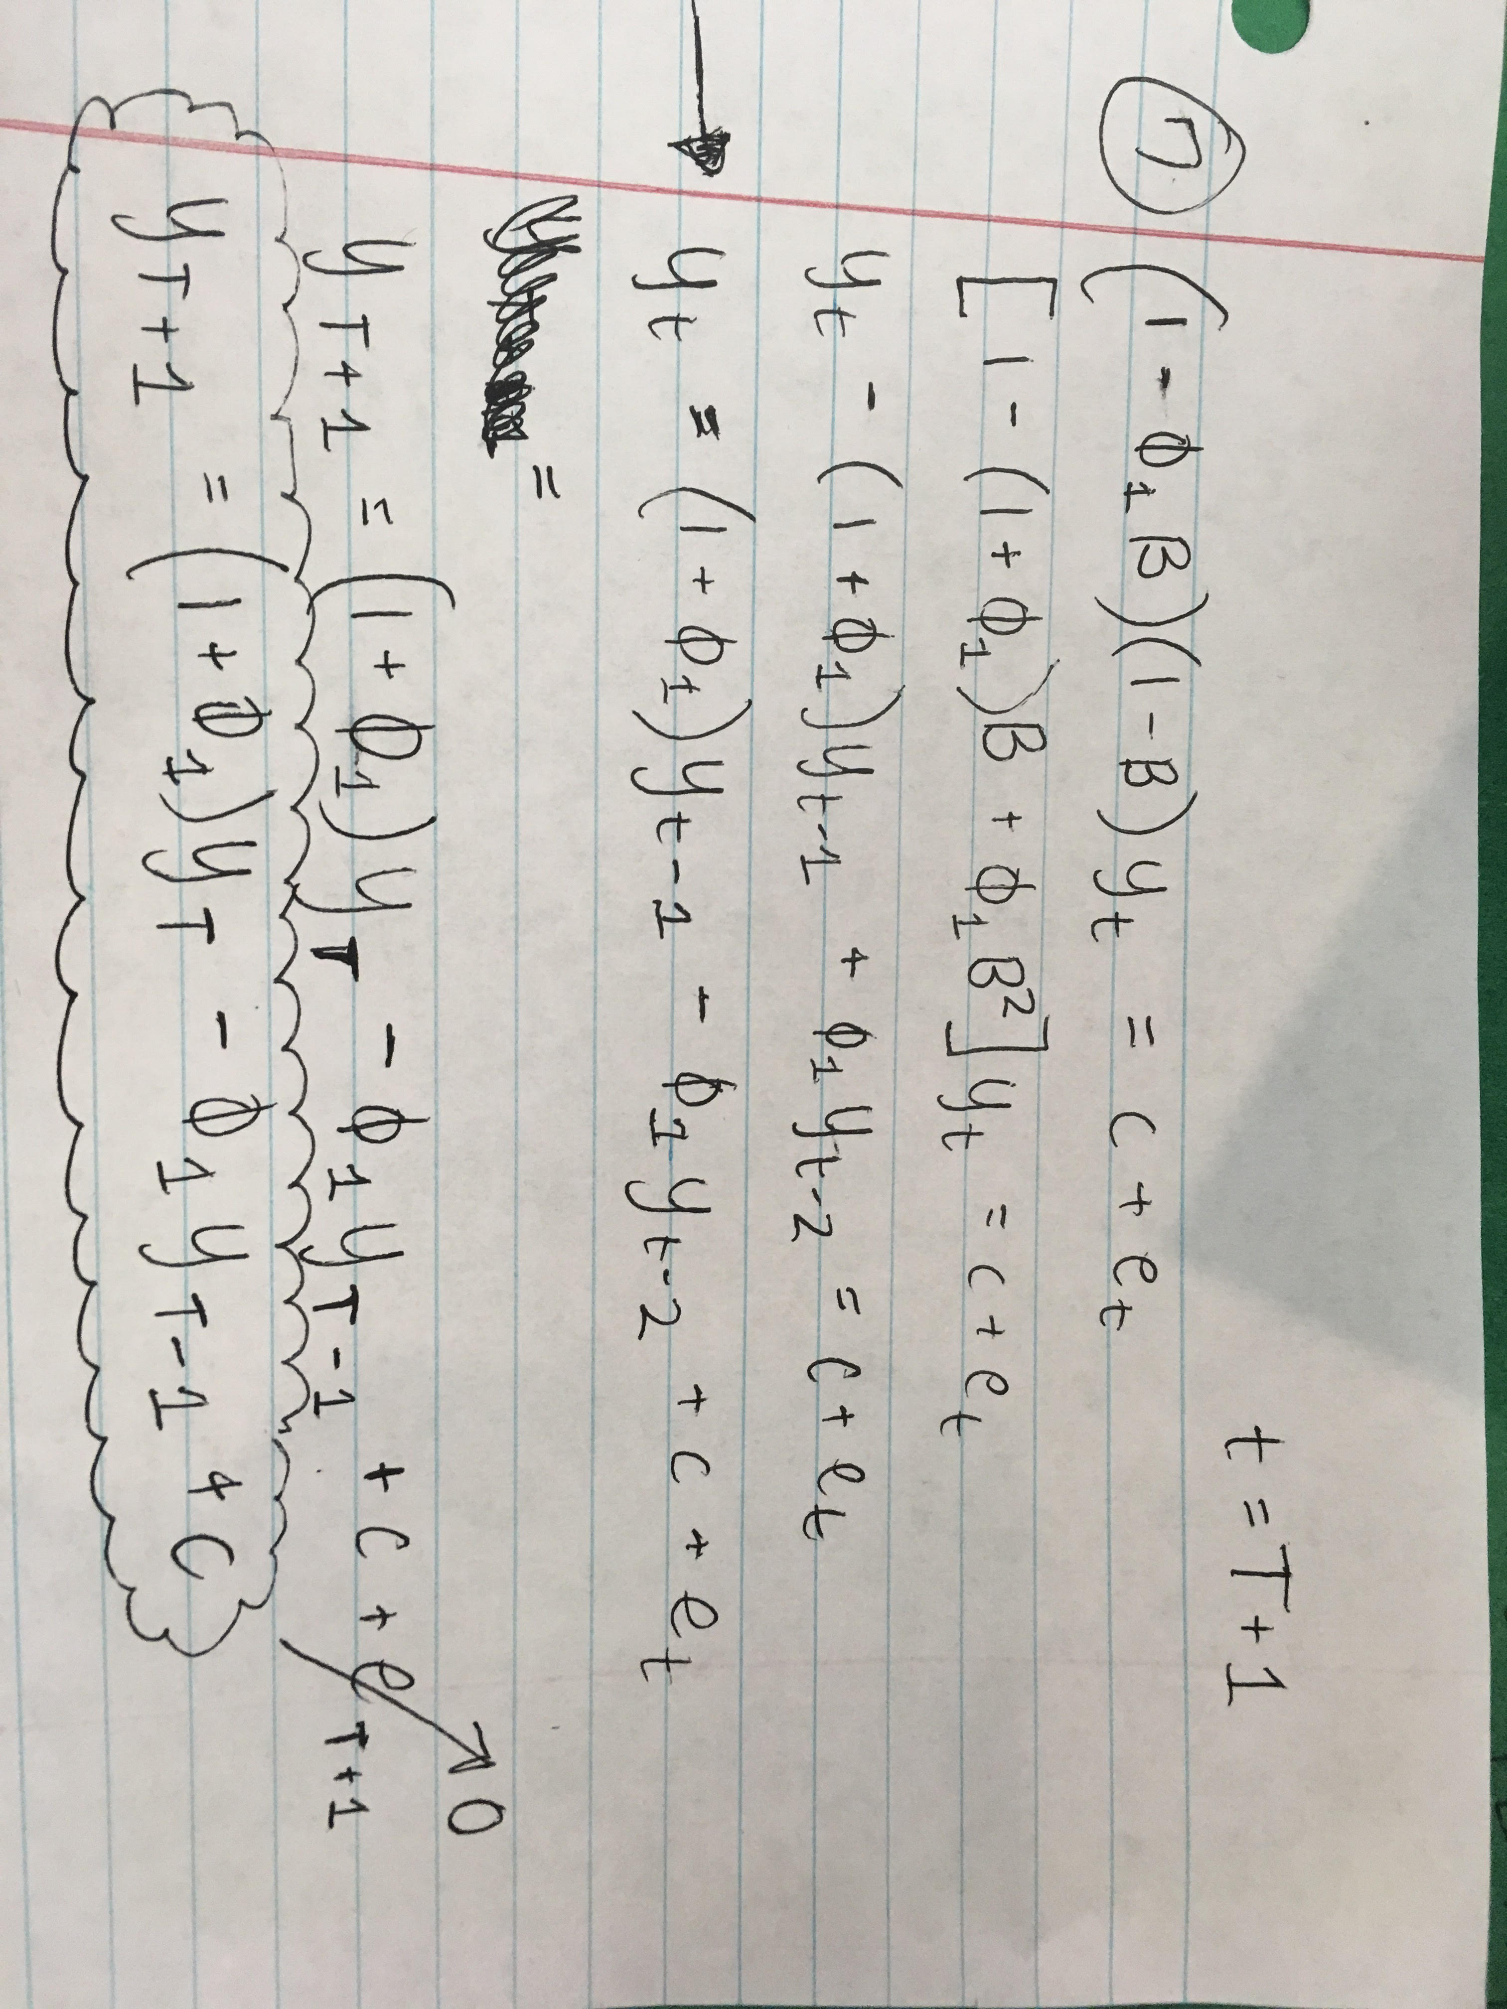

1. (5 pts) Replace the values of the parameters and write in explicit form the forecasting models for 2014, 2015 and 2016 as prepared at the end of 2013.

${\hat{y}}_{2014 | 2013}=$ see picture on next page

${\hat{y}}_{2015 | 2013}=$ see picture on next page

${\hat{y}}_{2016 | 2013}=$ see picture on next page

